My Vocabulary Video

Name ________________ Story/Topic____________

___ Fill out your vocabulary video planning sheet.
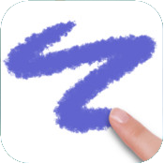
___ Take pictures of your vocabulary
words or draw them.
Save images to your camera roll.
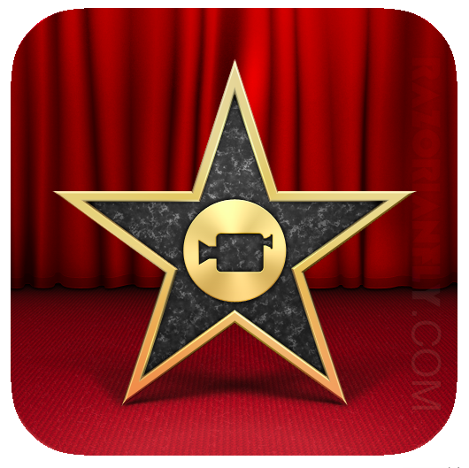
___ Put these pictures into a new iMovie
project.

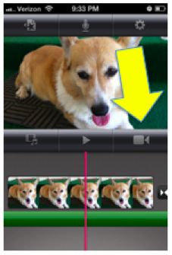
___ Video record yourself after each
picture to record you reading your
matching sentence.

___ Add titles to each picture with
the word. (Tap tap the picture in
the bottom frame, title style, middle.)

___ Add music (5 minute time limit
to choose.)

___ Share your complete project with the class!

Vocabulary Video
Planning Sheet

Name _____________________ Story/Topic________________

Word and Sentence:
1. _______________
________________________________________________________________________________________________________

2. _______________
________________________________________________________________________________________________________

3. _______________
________________________________________________________________________________________________________

4. _______________
________________________________________________________________________________________________________

5. _______________
________________________________________________________________________________________________________

Vocabulary Video
Planning Sheet

Name __ Suzie Sample __________ Story/Topic___ PRIDE _______

Word and Sentence:
1. Positive – sure, certain, helpful
_I try and share my positive attitude with others because I think it is very contagious.__

2. Responsible – person that can be trusted
__I am responsible for all my daily assignments and when I finish early, I try to help my friends.__

3. Inquisitive – questioning, curious
__My friends are extremely inquisitive and I appreciate how much they challenge me to think differently.__

4. Determined – able to solve a problem
__Everyone on my team is determined to succeed because we all know we are in this together, one for all and all for one!__

5. Enthusiastic – very excited about or interested
__I am highly enthusiastic and eager to learn about new apps that can help me create beautiful works of art.___

